Our Burndown Chart (Test Sprint 1):

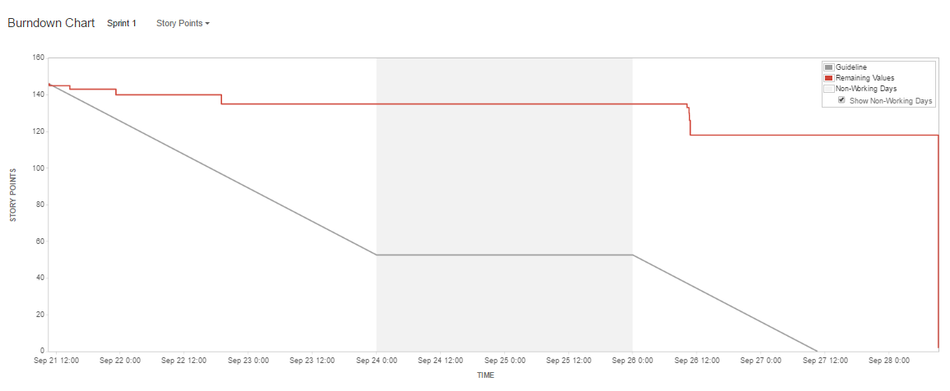

Explanation:

At the beginning of the sprint team members were moving tasks over, then as the sprint moved into the weekend progress halted. The large drop at the end of the sprint was a result of a 100-point task mistakenly placed in the sprint being resolved. The small gap left was a result in tasks left incomplete by a team member.